MATHEMATICS APPLICATIONS

MAWA Semester 1 (Unit 3) Examination 2016

Calculator-free

Marking Key

Section One: Calculator-free (50 Marks)

Question 1 (a)
Solution

The worker determined the degree of each vertex and concluded that the network had no odd vertices.
Marking key/mathematical behaviours | Marks
- determines degree of each vertex  - identifies there are no odd vertices | 1  1

Question 1 (b)
Solution

Eulerian.
Marking key/mathematical behaviours | Marks
- identifies type of trail | 1

Question 1 (c)
Solution

T A B E F B C D B H G F H T (or reverse order)
T A B C D B H G F B E F H T (or reverse order)
Marking key/mathematical behaviours | Marks
- lists first seven vertices in correct order  - lists remaining seven vertices in correct order | 1  1

Question 2 (a)
Solution

The relationship is weak. The correlation coefficient is about 0.45 OR the data points do not form a close linear pattern.
Marking key/mathematical behaviours | Marks
- describes the strength of the linear relationship  - justifies conclusion | 1  1

Question 2 (b)
Solution

(i) There would be about 10 burglaries
(ii) As the number of assaults increases by 1 the number of burglaries decreases by 1.
Marking key/mathematical behaviours | Marks
- interprets the y-intercept  - describes the change as negative  - identifies the rate of change as 1 for 1 [1 mark for each value] | 1  1  2

Question 3 (a)
Solution
Marking key/mathematical behaviours | Marks
- identifies correct edges for Town 7  - identifies correct edges for Town 8  - identifies correct edges for Town 9 | 1  1  1

Question 3 (b)
Solution

(i) when it can be drawn on a sheet of paper without any edges crossing
(ii)
Marking key/mathematical behaviours | Marks
- describes planarity  - connects all towns with their respective services  - draws network without any edges crossing | 1  1  1

Question 3(c)
Solution

(i) Bank
(ii) Graph showing direct edge from Town 9 to the bank.

It is impossible to draw an edge from Town 9 to the bank without crossing another edge
Marking key/mathematical behaviours | Marks
- (i) designates that a bank is the additional service  - (ii) draws a graph showing edge from Town 9 to bank  - draws with correct edges crossing | 1  1  1

Question 4 (a)
Solution

Letters A, C and D should be circled
Marking key/mathematical behaviours | Marks
- selects one correct feature  - selects second correct feature  - selects third correct feature (only selecting 3) | 1  1  1

Question 4 (b)
Solution

Cannot travel every edge only once AND start and finish at same vertex
Marking key/mathematical behaviours | Marks
- describes first condition  - describes second condition | 1  1
© MAWA, 2016
This examination is Copyright but may be freely used within the school that purchases this licence.
- The items that are contained in this examination are to be used solely in the school for which they are purchased.
- They are not to be shared in any manner with a school which has not purchased their own licence.
- The items and the solutions/marking keys are to be kept confidentially and not copied or made available to anyone who is not a teacher at the school. Teachers may give feedback to students in the form of showing them how the work is marked but students are not to retain a copy of the paper or marking guide until the agreed release date stipulated in the purchasing agreement/licence.
Published by The Mathematical Association of WA
12 Cobbler Place, MIRRABOOKA 6…

Question 4 (c)
Solution

Euler’s Rule : n(vertices) + n(faces) – n(edges) = 2
5 + 3 – 6 = 2
Marking key/mathematical behaviours | Marks
- states Euler’s Rule  - substitutes correct number of vertices, faces and edges | 1  1

Question 4 (d)
Solution

Graph is still connected when edge PQ is removed
Marking key/mathematical behaviours | Marks
- explains graph remains connected  - when edge PQ removed | 1  1

Question 4 (e)
Solution

The degree of vertex R is 3 because exactly 3 edges meet at R .
Marking key/mathematical behaviours | Marks
- identifies degree of node  - justifies choice of value | 1  1

Question 5 (a)
Solution
Number of hours pump was working | 1 | 2 | 3 | 5 | 6
Volume of water in the tank (in litres) | 360 | 560 | 760 | 1160 | 1360

Marking key/mathematical behaviours | Marks
- determines starting value and third term  - determines 5th term  - identifies term number | 1  1  1

Question 5 (b)
Solution

760 litres
Marking key/mathematical behaviours | Marks
- relates sequence to context of problem | 1

Question 5 (c)
Solution
$T_{n+1 = }T_{n + }$200 $T_{1}$= 360
Marking key/mathematical behaviours | Marks
- describes recursive relation  - identifies starting term (or any particular term) | 1  1

Question 5 (d)
Solution

Linear. The increase is a constant number
Marking key/mathematical behaviours | Marks
- identifies correct relationship  - justifies choice of type | 1  1

Question 5 (e)
Solution

1960
Marking key/mathematical behaviours | Marks
- identifies correct term (n = 9)  - determines correct value | 1  1

Question 5 (f)
Solution

18 hours
Marking key/mathematical behaviours | Marks
- identifies correct term | 1

Question 6 (a)
Solution

6
Marking key/mathematical behaviours | Marks
- identifies Hamiltonian circuits | 1

Question 6 (b)
Solution

WXYZW or WZYXW 63 km
Marking key/mathematical behaviours | Marks
- identifies shortest circuit  - determines length of shortest circuit | 1  1

Question 6 (c)
Solution

It goes through each vertex only once
It starts and ends at the same vertex
Marking key/mathematical behaviours | Marks
- identifies cyclic nature  - describes path though vertices | 1  1

Question 6 (d)
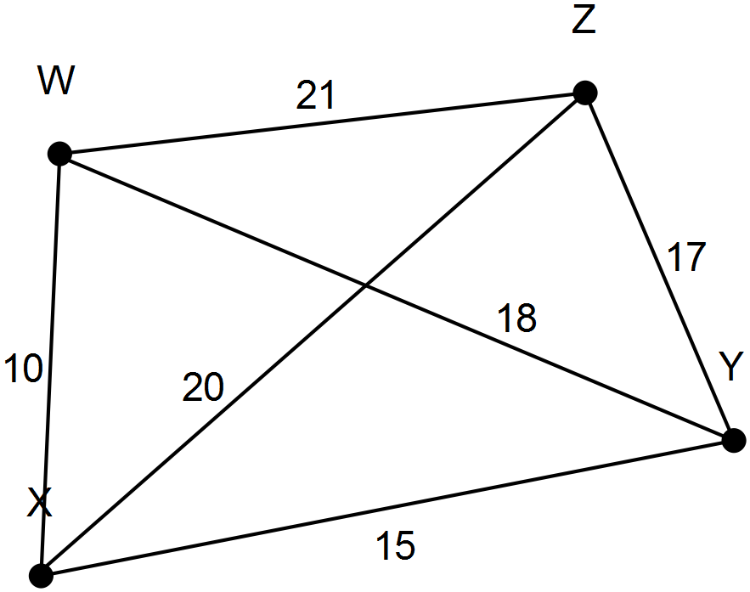Solution

Marking key/mathematical behaviours | Marks
- uses and labels correct number of nodes  - completes all edges  - places correct weights on all edges | 1  1  1

